**Team JARVIS**

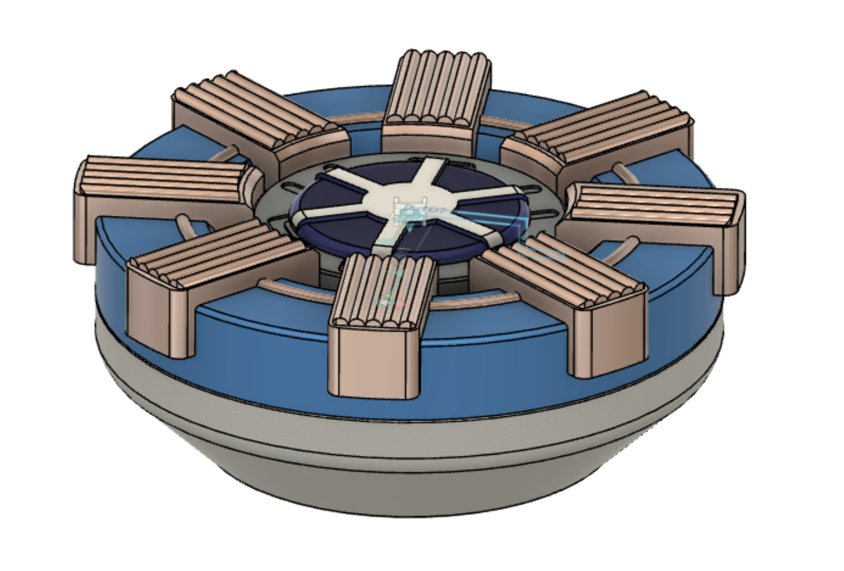

**Branden Morioka**

**Helen Read**

**Matthias Johannes**

**Nisal Ovitigala**

**Smita Bhattacharjee**

**TUESDAY PM**

**1. Final Yoyo Design/ Toolings**

Our Yoyo design is the face of the Iron Man Arc Reactor. We decided to create the Arc reactor face as the main body of our yoyo, which consisted of four different parts. Pictures of the final yoyo design with the components as well as a sectioned view is below to help contextualize how each piece fits together.

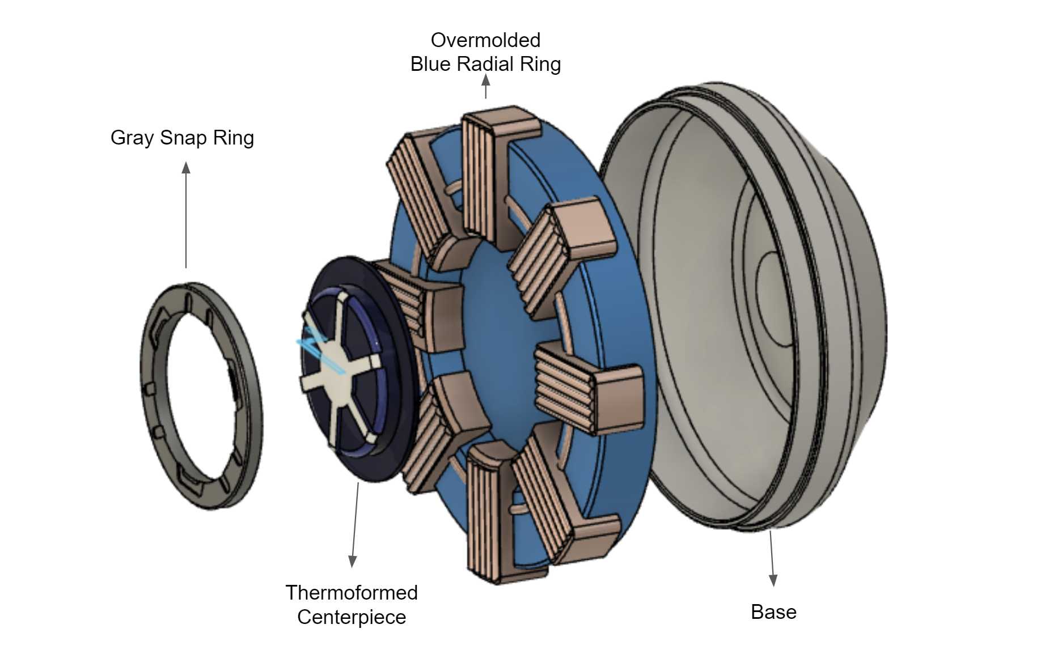



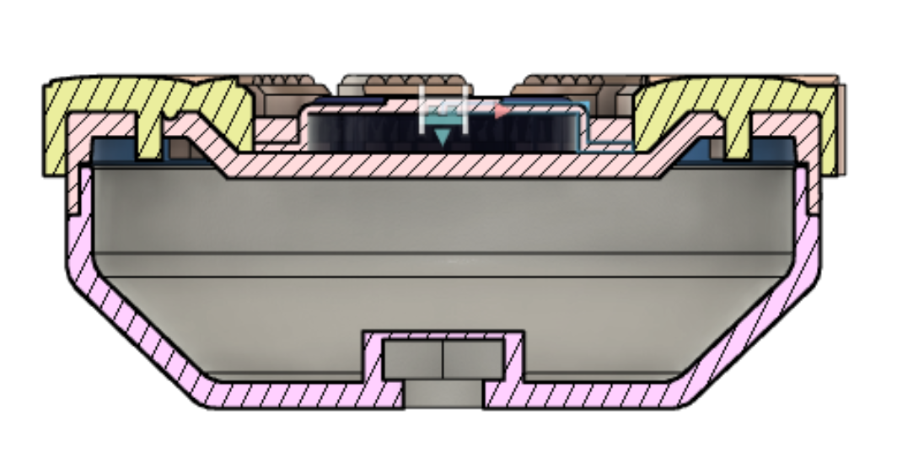

**Key Design Considerations throughout the Semester**

There were several different considerations we had to understand to make our yoyo possible. The major considerations are listed below:

Design Phase

* Critical dimensions that would ensure snap fit
* Make sure our parts were manufacturable
  + After first design review we had to redesign a part that would have been hard to manufacture, so we made the overmold ring

Overmold Feature

* Planning for shrinkage
* Aesthetic tradeoffs
  + We could only have 2 colors with an overmold piece so we couldn’t do black borders around the orange coils as originally planned
* Creating 2 sets of molds for 1 part

Making the Molds

* Adjusting designs based on issues with machining and toolpaths( ie. overhangs, impossible tool paths)
  + Had to adjust our design to have a visible orange ring because the previous iteration would have created an overhang in the mold
* Picking a parting line that creates optimal molds both aesthetically and to create a machinable mold
* Adding the sprue and runners to both the parts and the molds
  + Understanding how this affects cooling and shrinkage (moldflow)
* Placing the ejector pins in locations that were effective but would not interfere with part finish
* Scaling up the parts to create core and cavities that would allow part to shrink to desired size
* Creating overmold tooling that allows for existing part to fit in and get closed off while the rest fills

**Manufacturing Tooling**

Below is our manufacturing tooling for each of the parts shown above.

1. **Base**

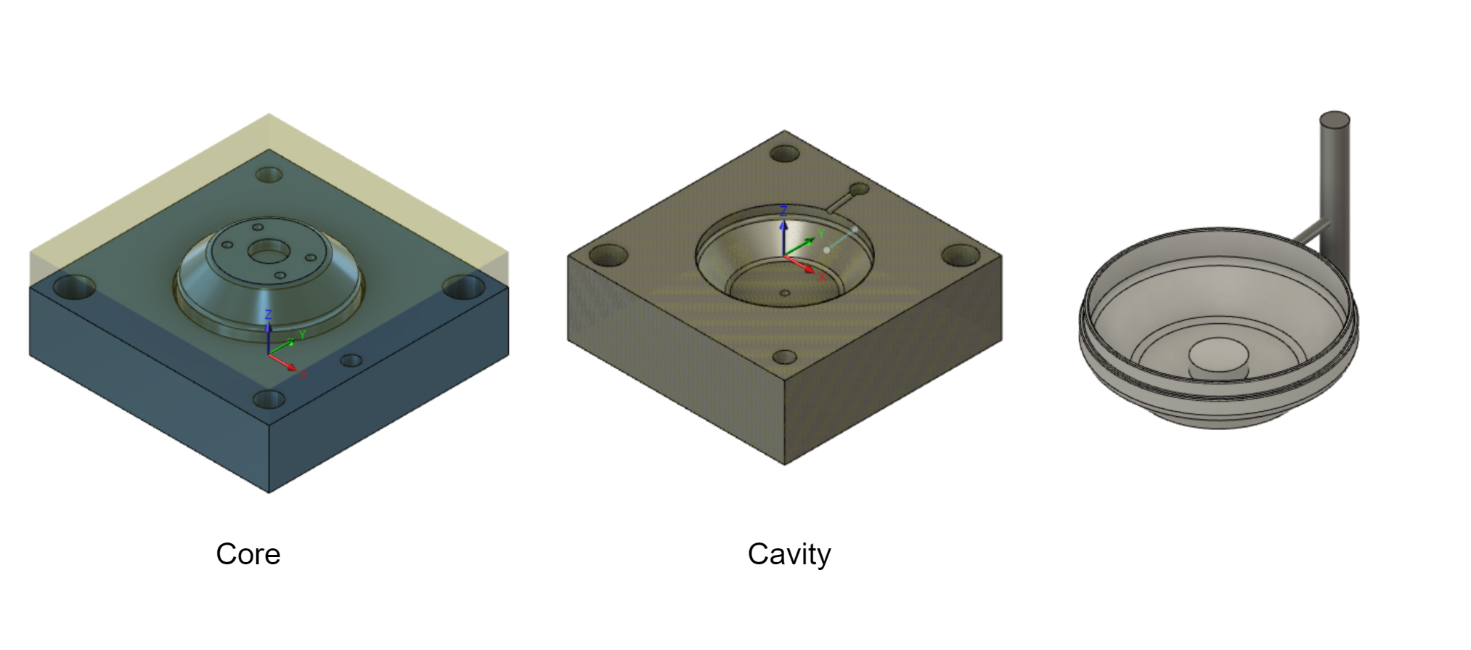

Cavity

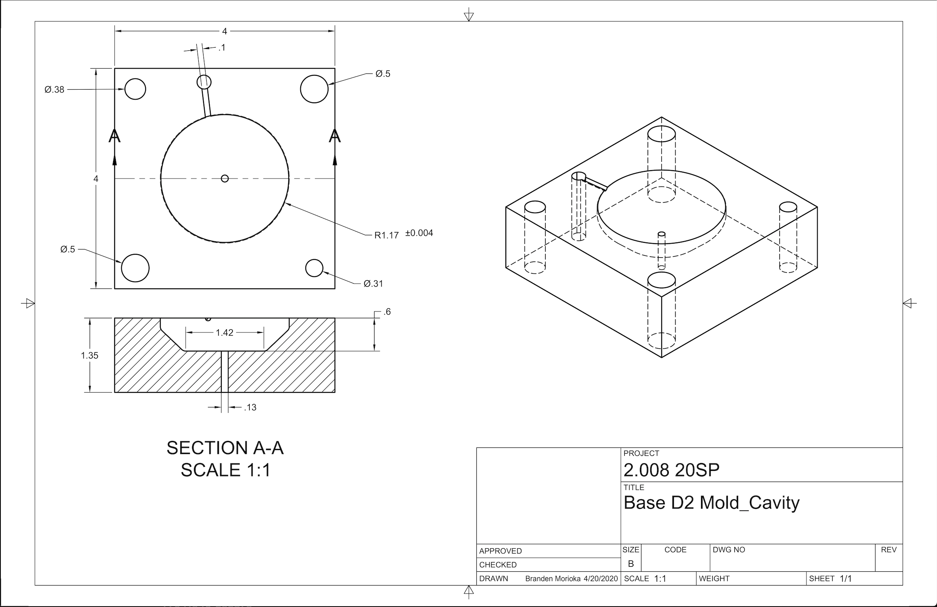

Core

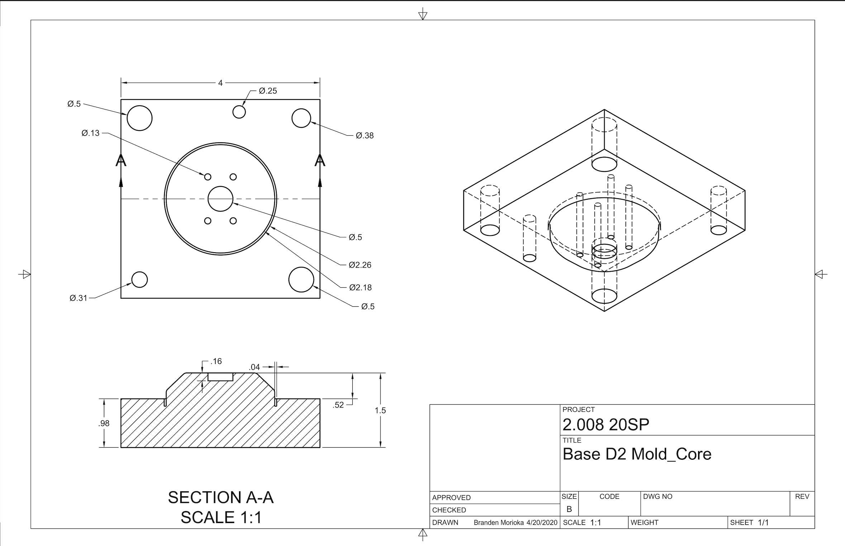

1. **Grey Snap Ring**

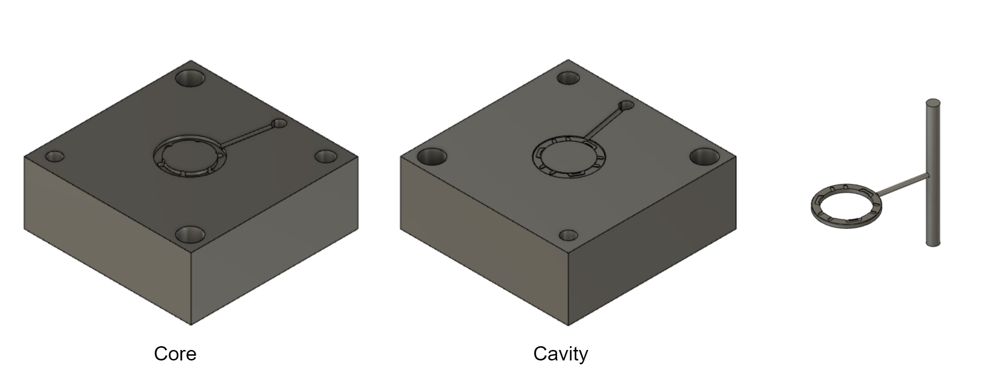

Core

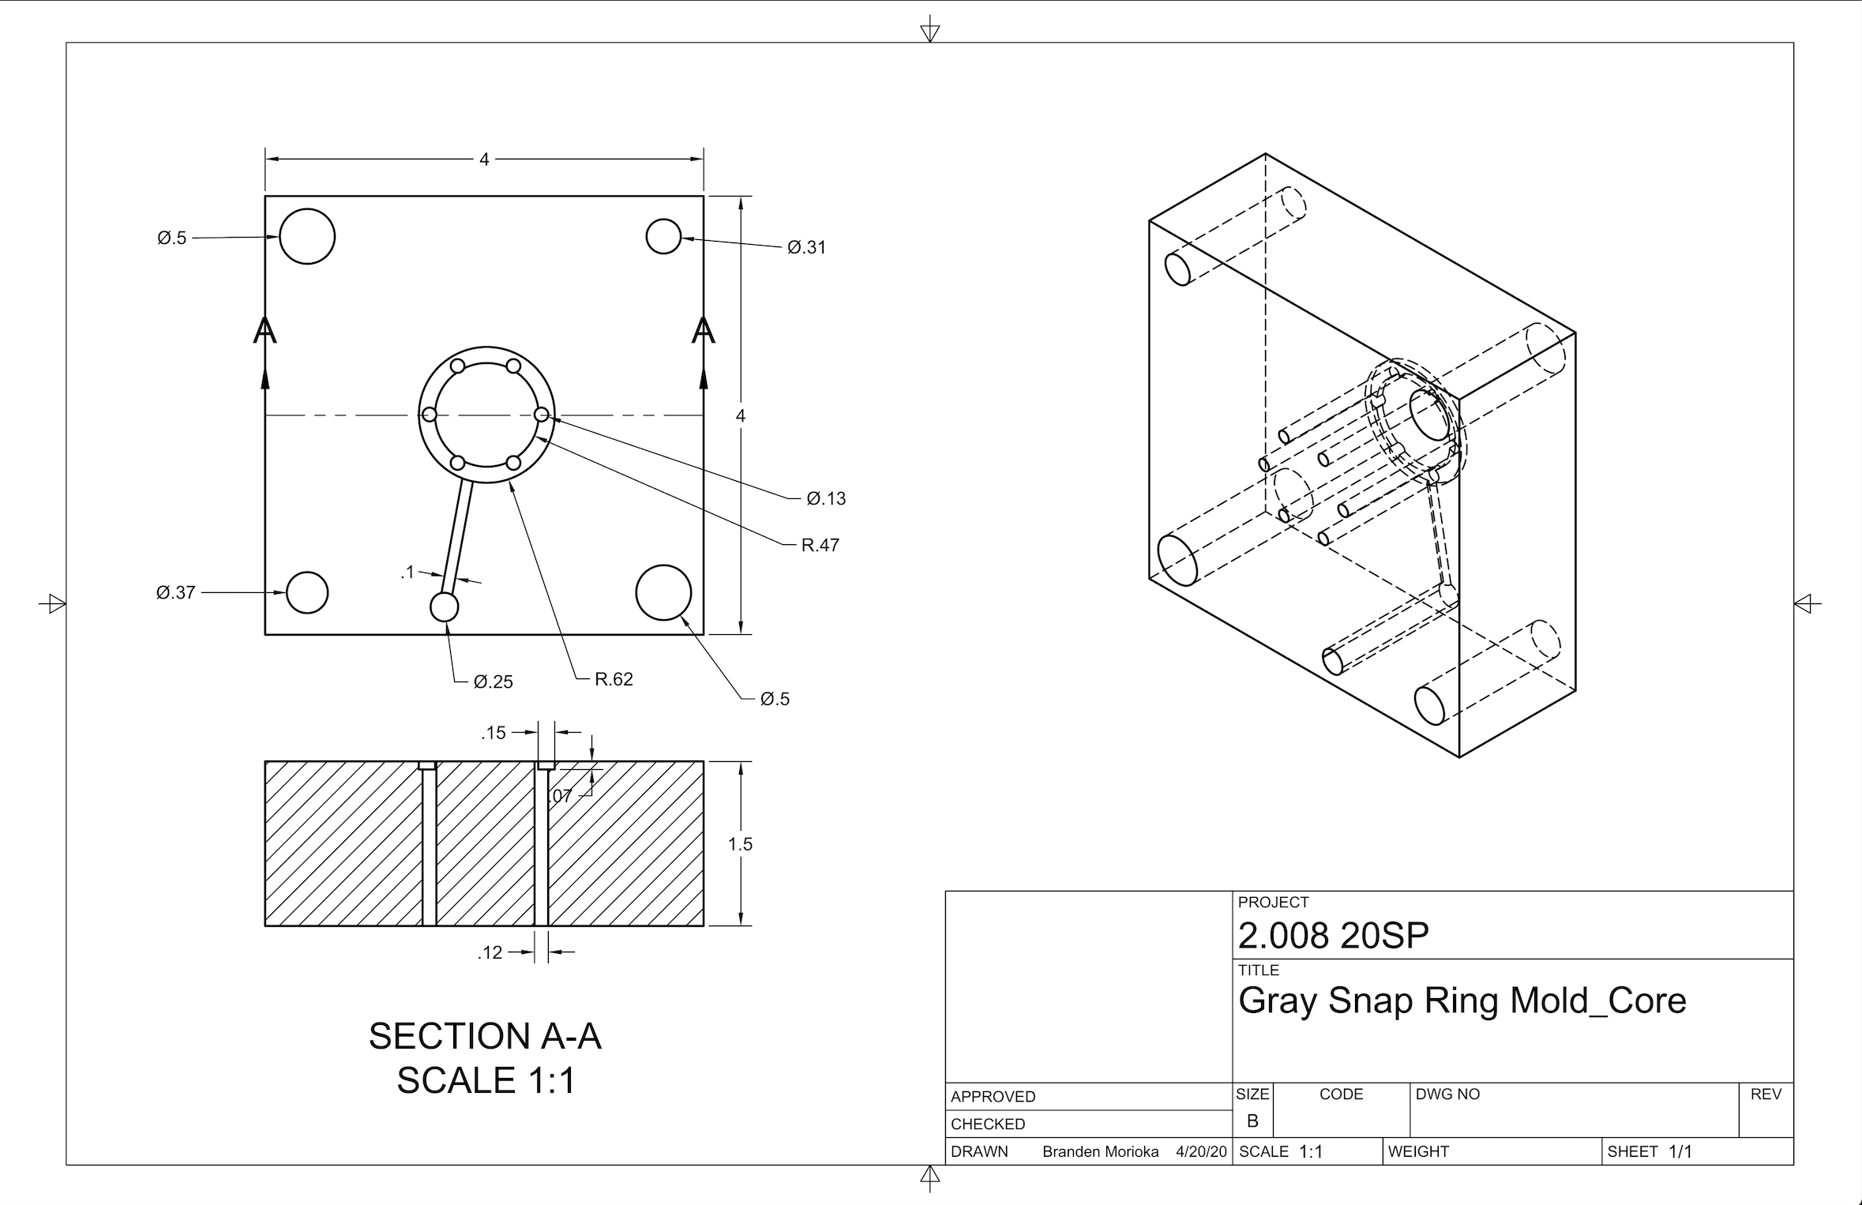

Cavity

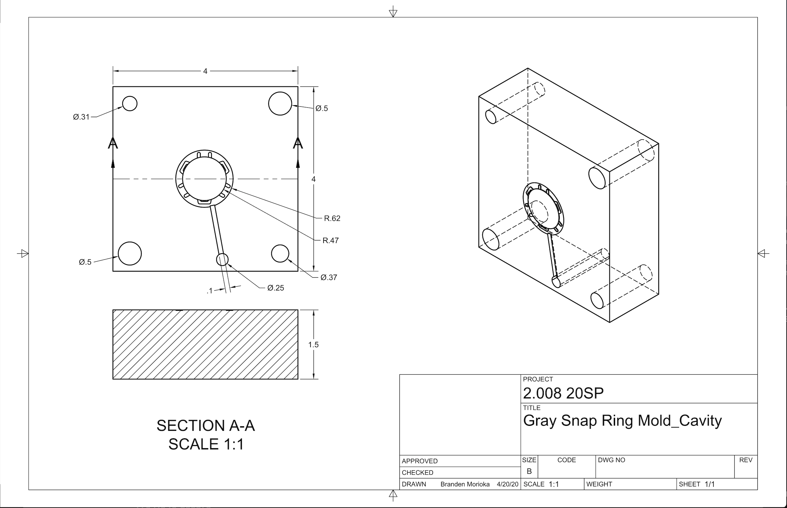

1. **Radial Ring**

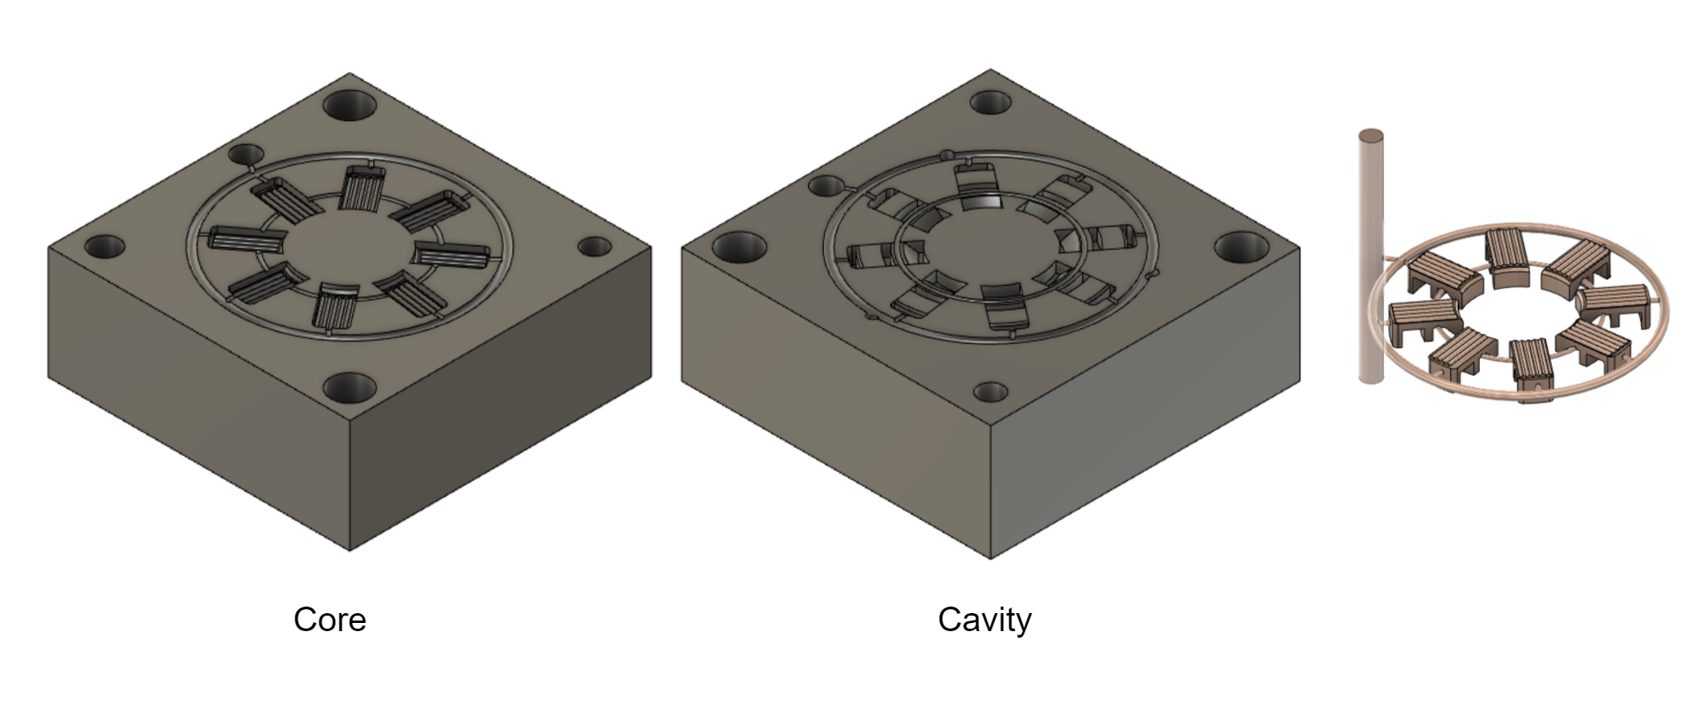

Core

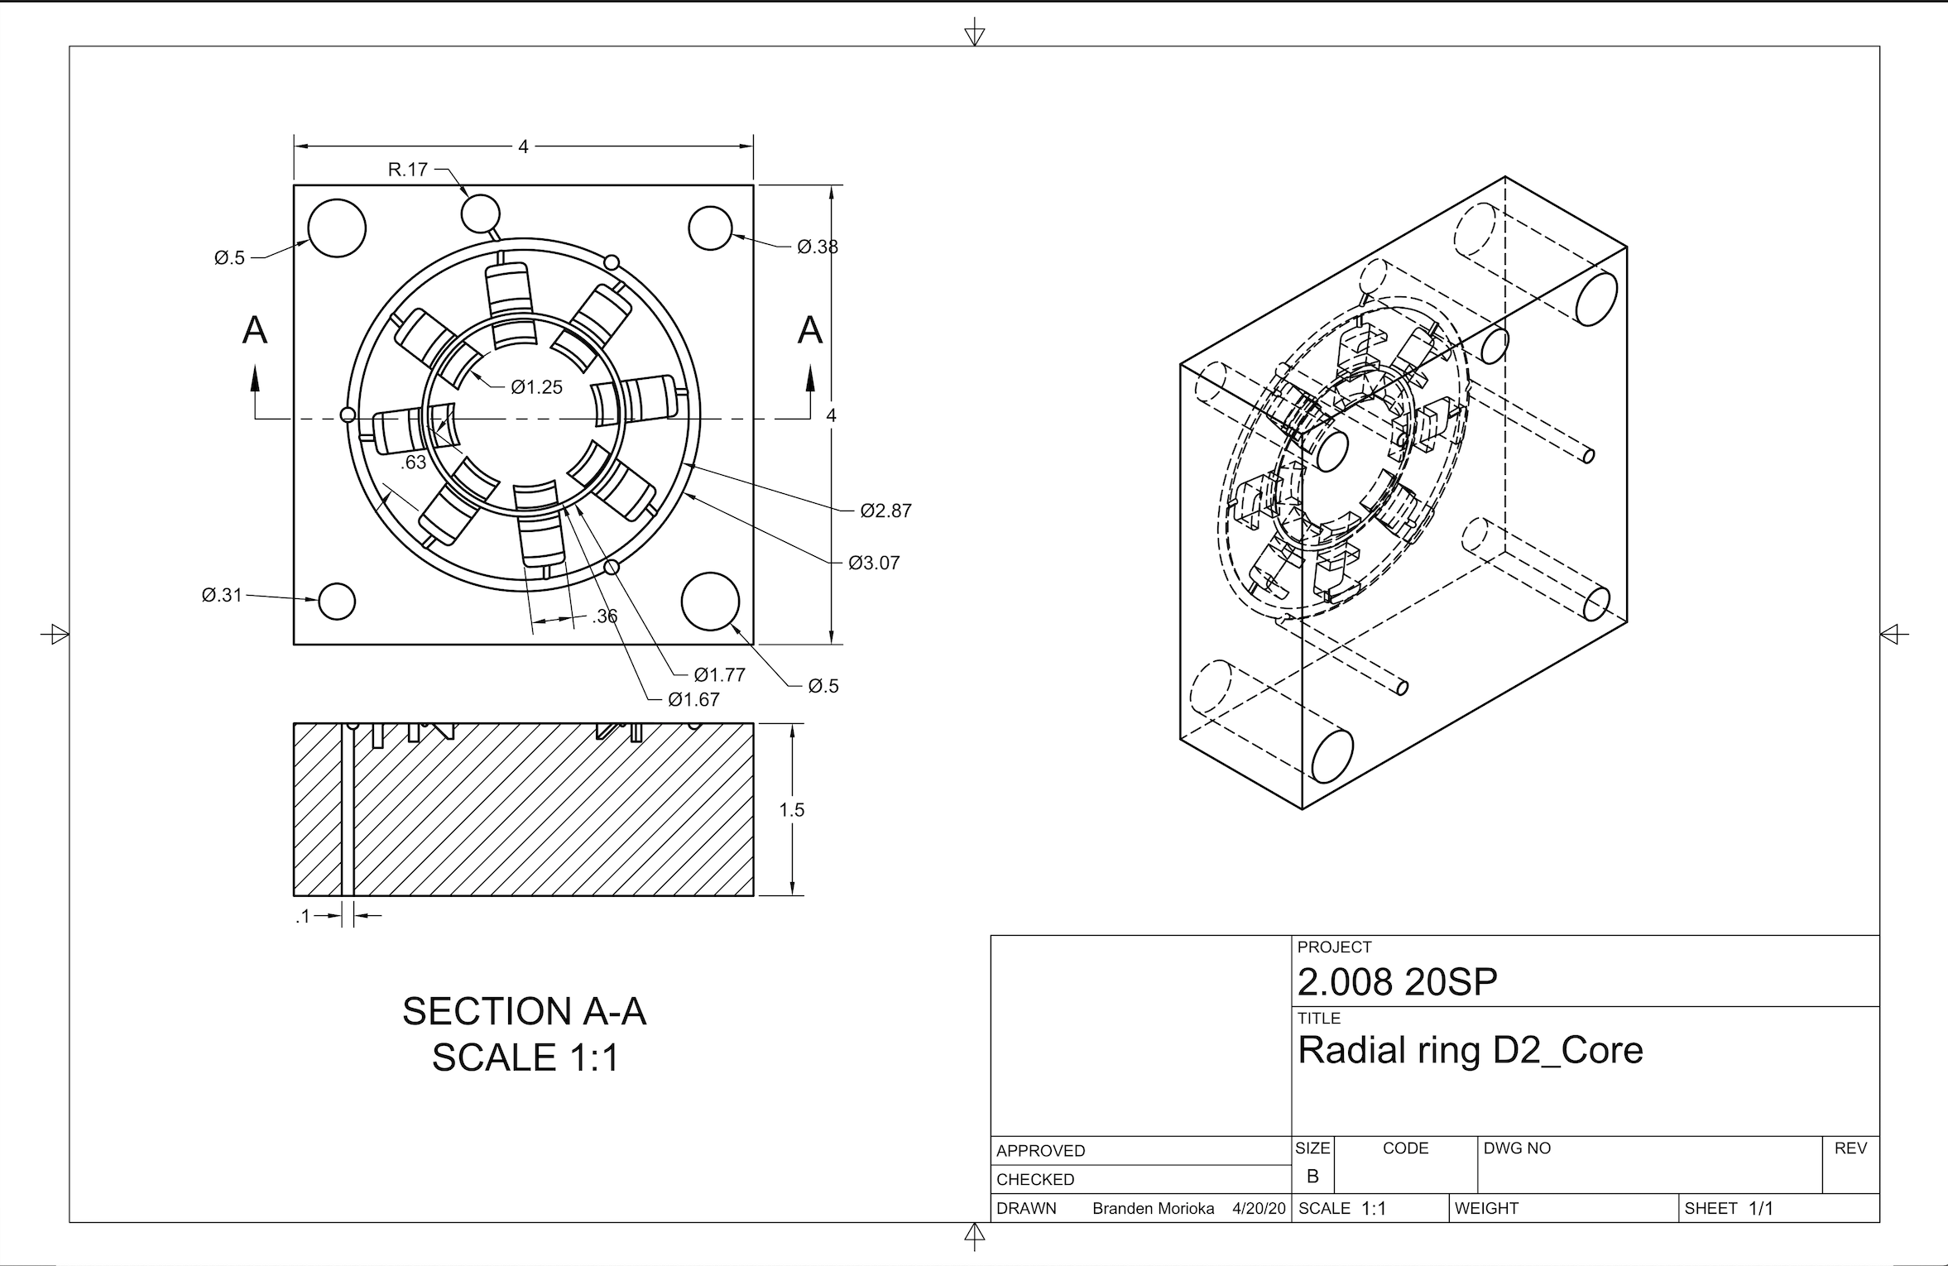

Cavity

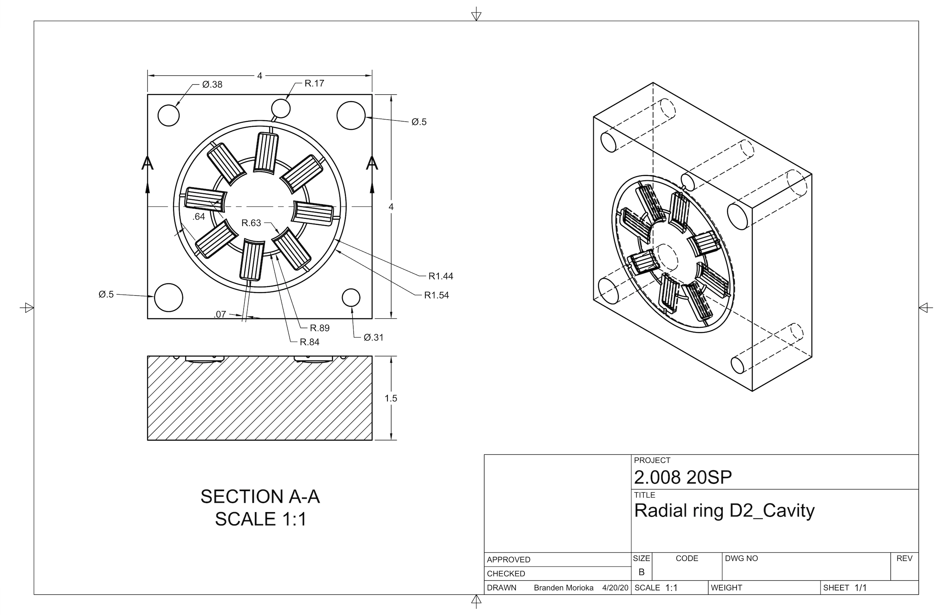

1. **Blue Snap Ring**

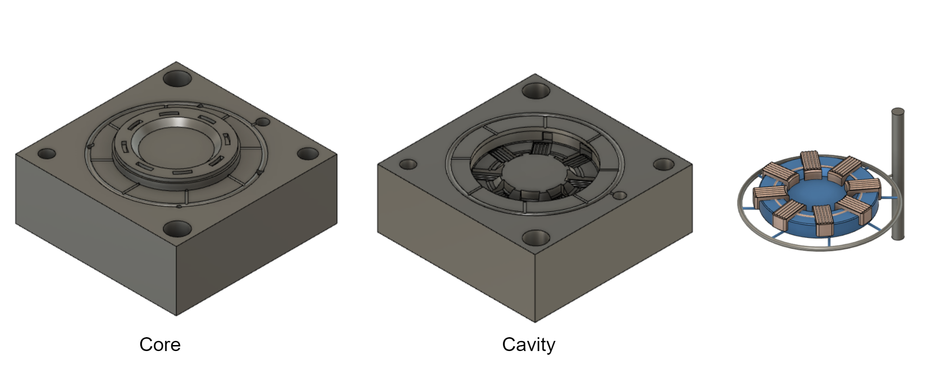

Core

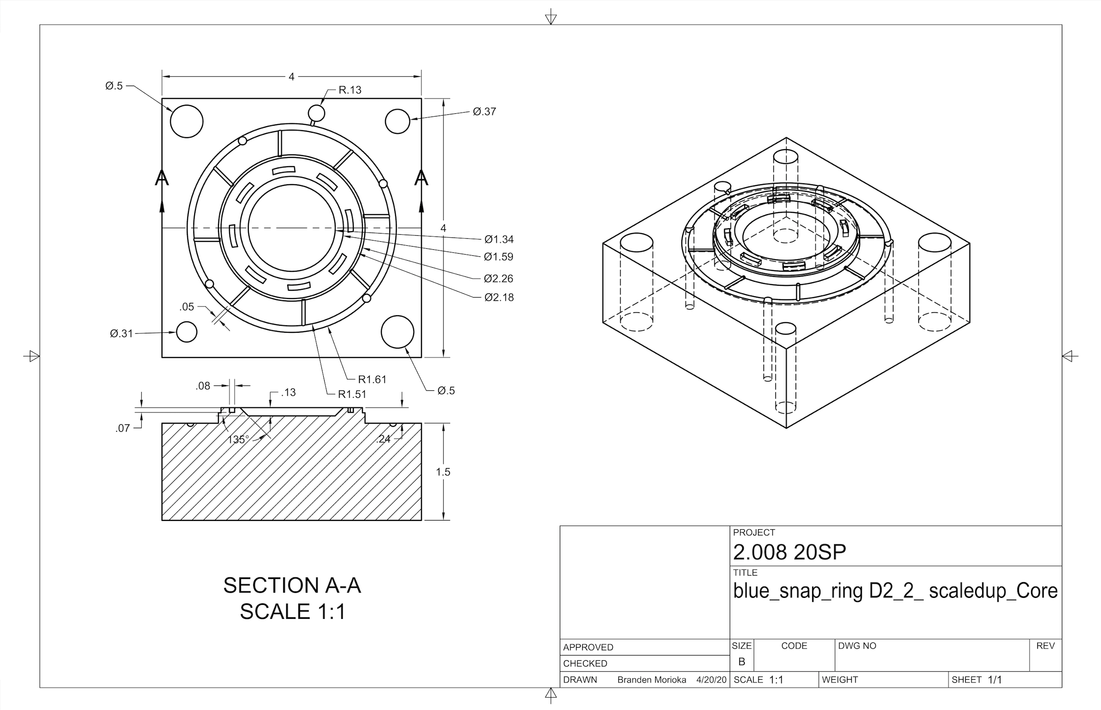

Cavity

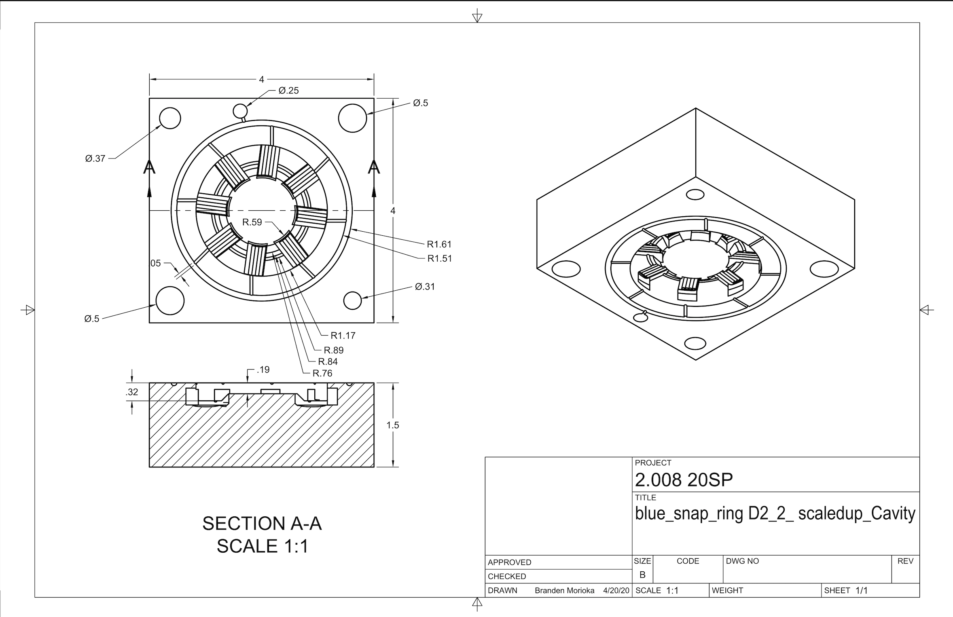

1. **Thermoformed Center Feature**

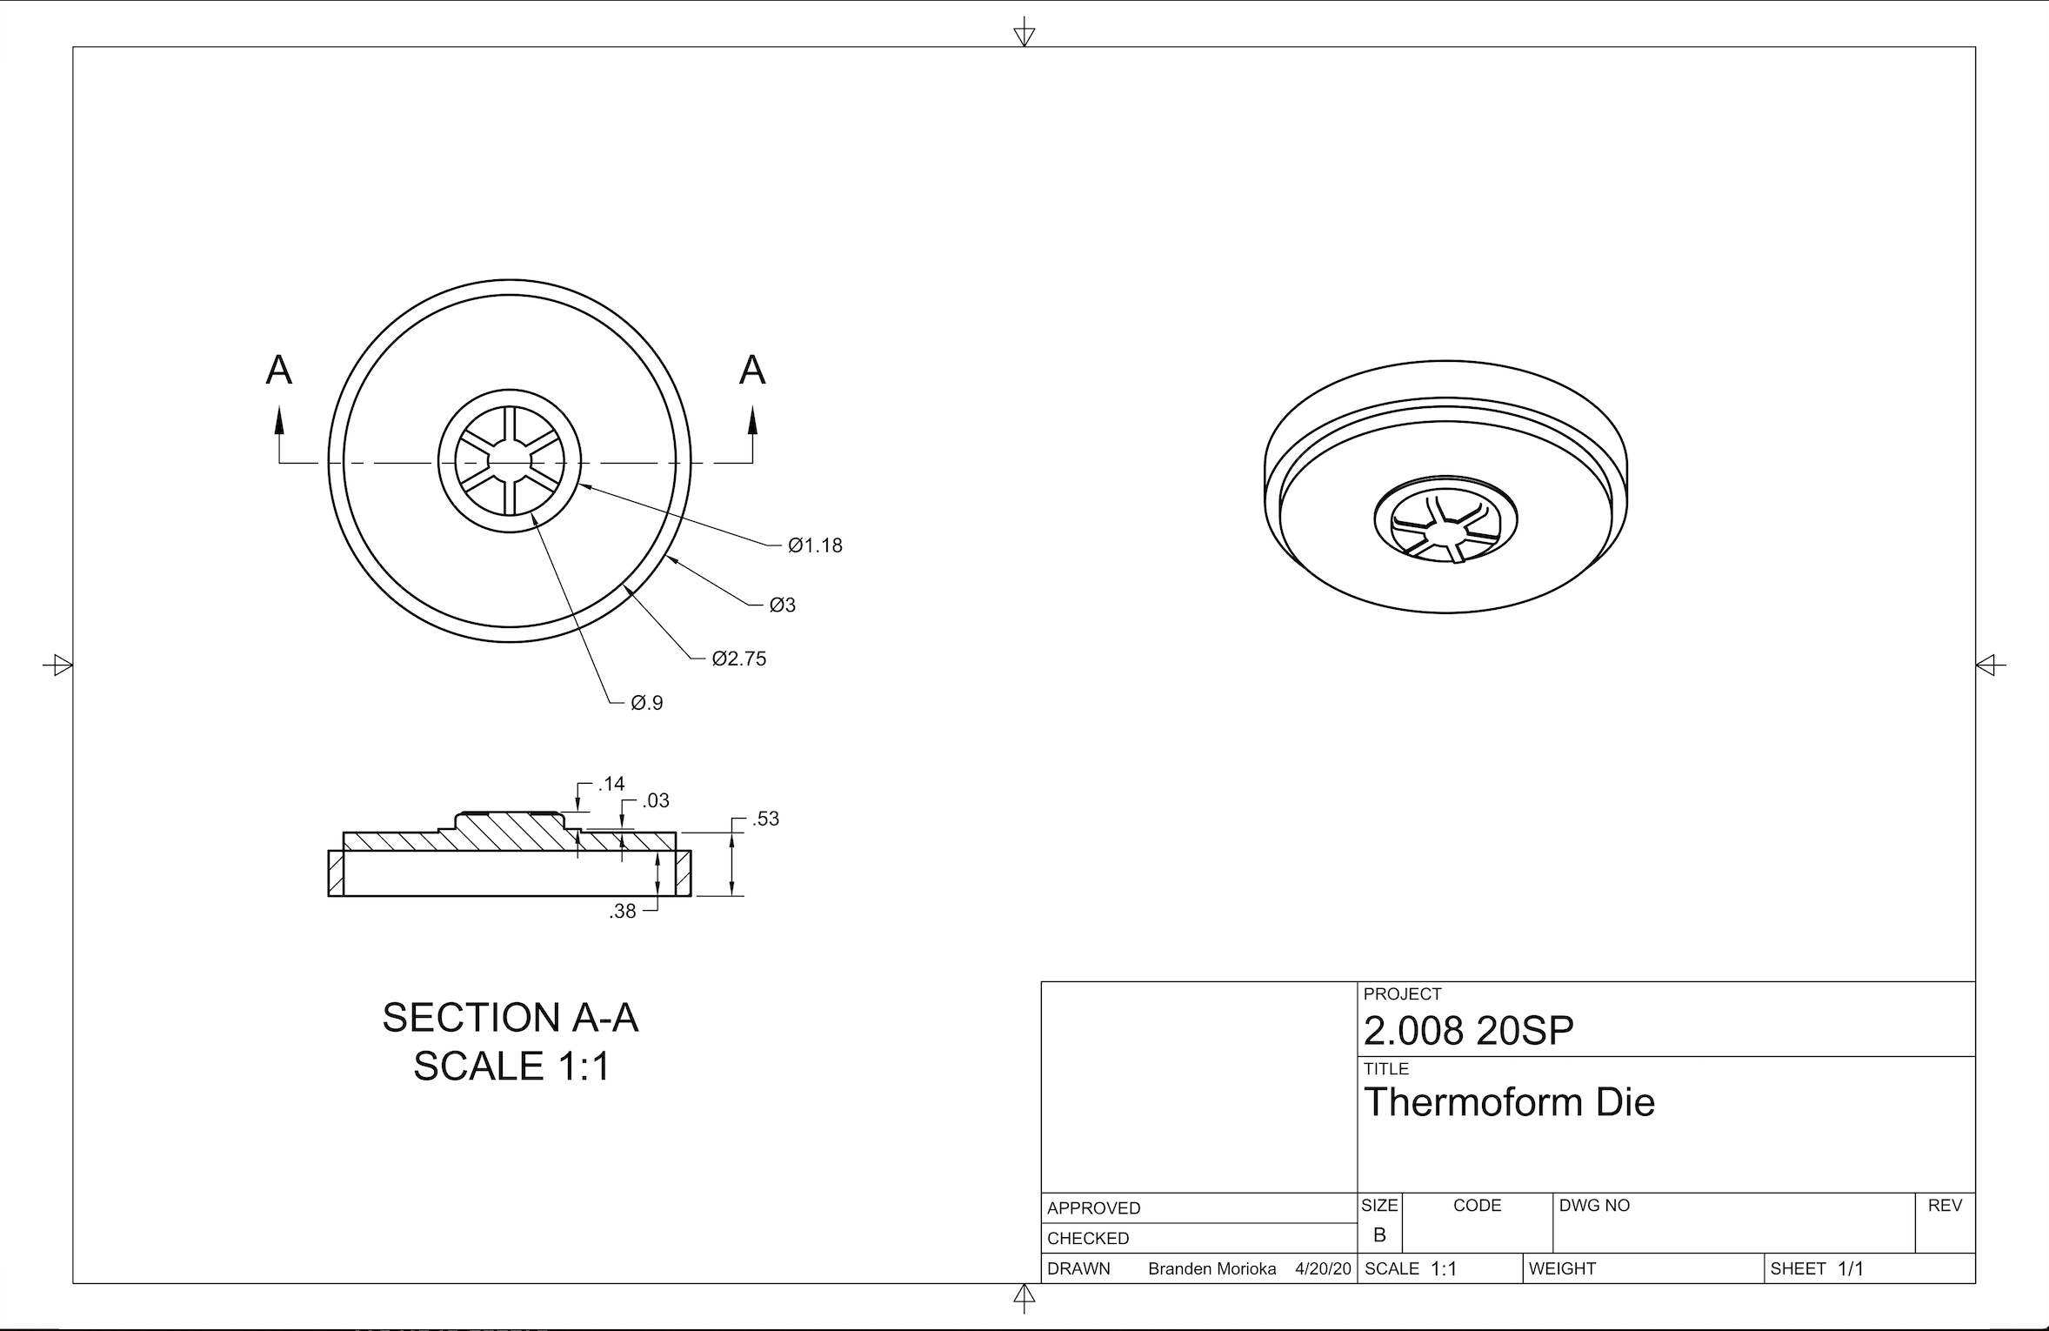

**2. Critical Dimensions**

When we were designing our yoyo, our team determined critical dimensions that would ensure a proper snap fit between each of our parts.The table with critical dimensions and tolerances is documented below.

We wanted to further expand on our assessment of critical dimensions using the Variation and Quality lesson to calculate the 3-sigma values using our design tolerances. For a process to be in control Cpk >1.33. Therefore we used this equation to solve for sigma and ensure that 99.7% of our parts would be in the right range:

$Cp=1.33= \frac{USL-LSL}{6σ}$

Using this formula and taking the upper and lower bounds of our tolerances for each critical dimension, the appropriate 3-sigma value could be found. This value represents the limit to variation that would allow the majority of parts to fall in the successful range to pass quality controls. The corresponding 3-sigma values are in the following table:

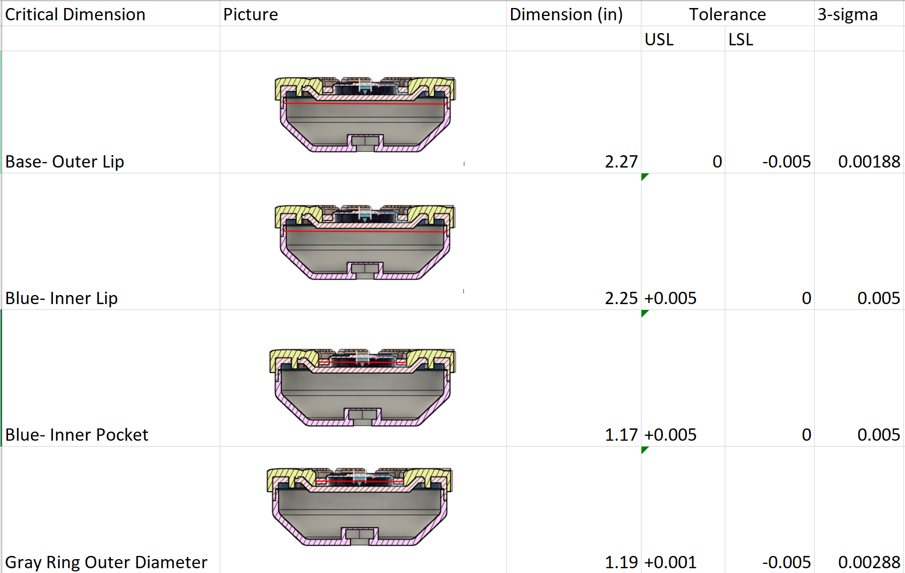

**3. Tecnomatix- Factory Layout**

For our factory layout, we knew that we would need separate channels for the different parts we were making. We knew we needed to have a thermoform station, injection molding machines for the base, gray snap ring, radial feature, and the blue ring overmold.

We decided to have the raw plastic pellets fed into the different injection molding machines along with the nut that has to get embedded, and had the PETG material being directly fed into the thermoform machine. The different plastic injection molded parts and the thermoform parts could occur in parallel with the exception of the overmold blue ring, which needed to be placed in series after the radial ring. Following that we have half assembly stations which involves snapping all the pieces together and then a full assembly station which incorporates the yoyo string and set screw. Buffers are interspersed between machines and processes. The basic process flow looked like this:

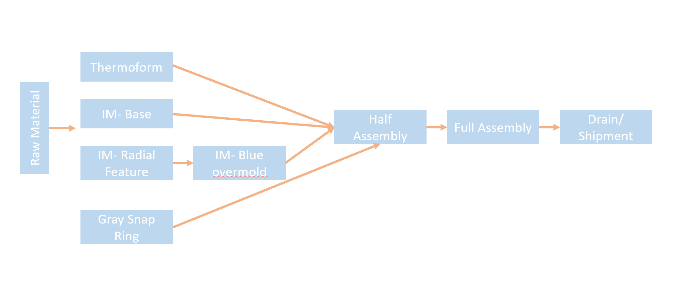

We also know that we wanted 1 million-10 million yoyos which meant that at a minimum 2,740 yoyos have to be made everyday. This gave us a target to aim for when running out simulations

We input this basic process flow into Tecnomatix and added other machines to help achieve the target production rate. We also added other necessary steps such as cutting the runner and sprue off and cutting the thermoform part to size. Using the cycle times we calculated in our Go To Manufacturing report (see appendix for cycle time breakdown), we ran the simulation and fine tuned the buffer sizes to meet our target production rate. We also estimated some of the cycle times based on our experiences with the yoyo parts mailed to us. The relevant parameters and quantities of each machine and our final factory layout are shown below:

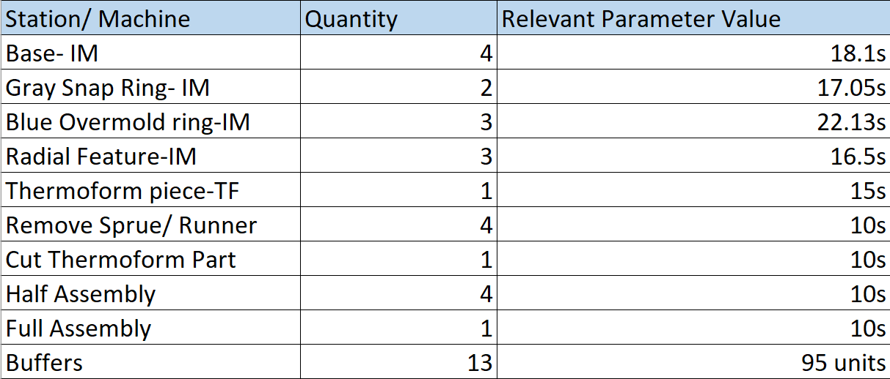

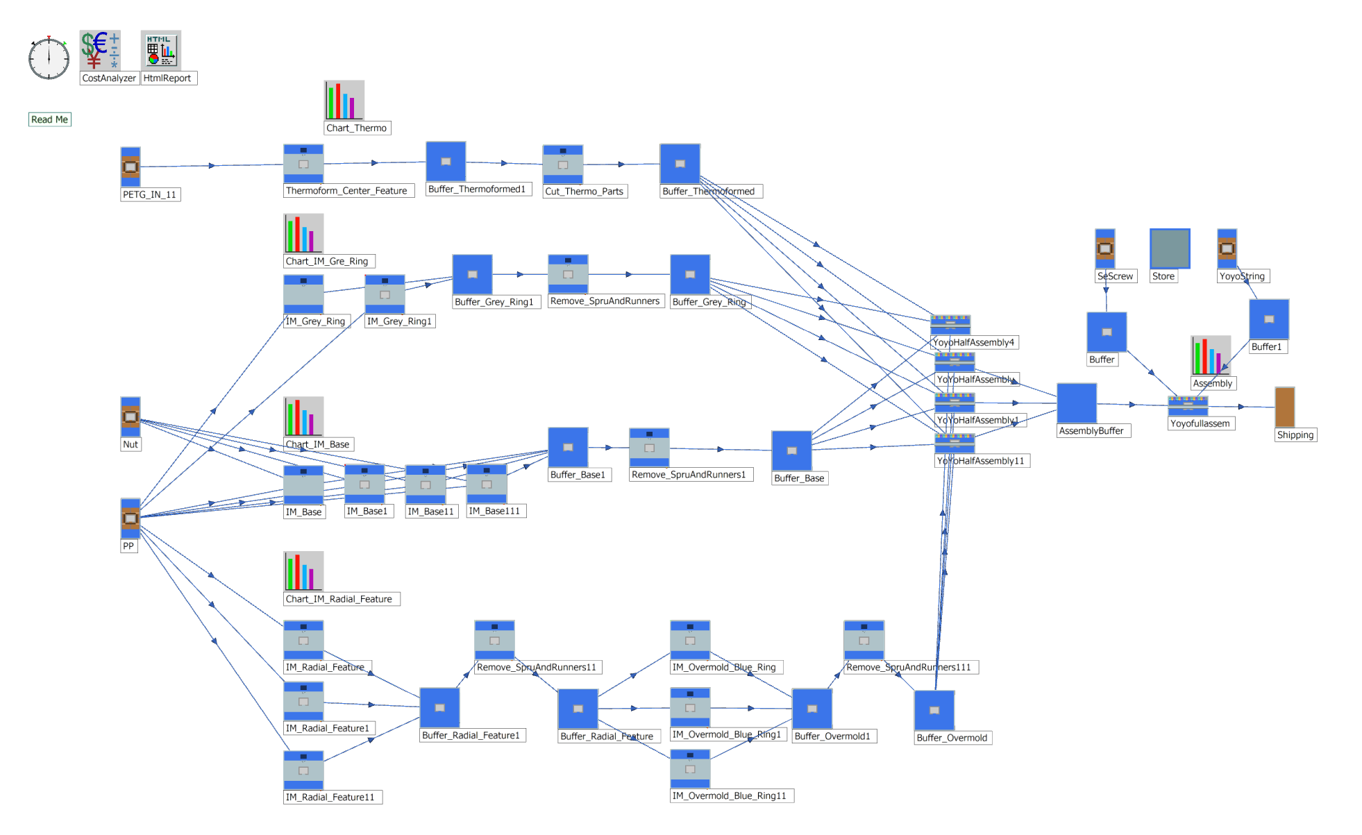

Our final production rate was 3,889 units per day which results in 1,419,485 total yoyos per year. The buffer size of 95 was the lowest number possible that could maintain this production rate, thus minimizing inventory as much as possible. The final results of the simulation are shown in the screen capture below:

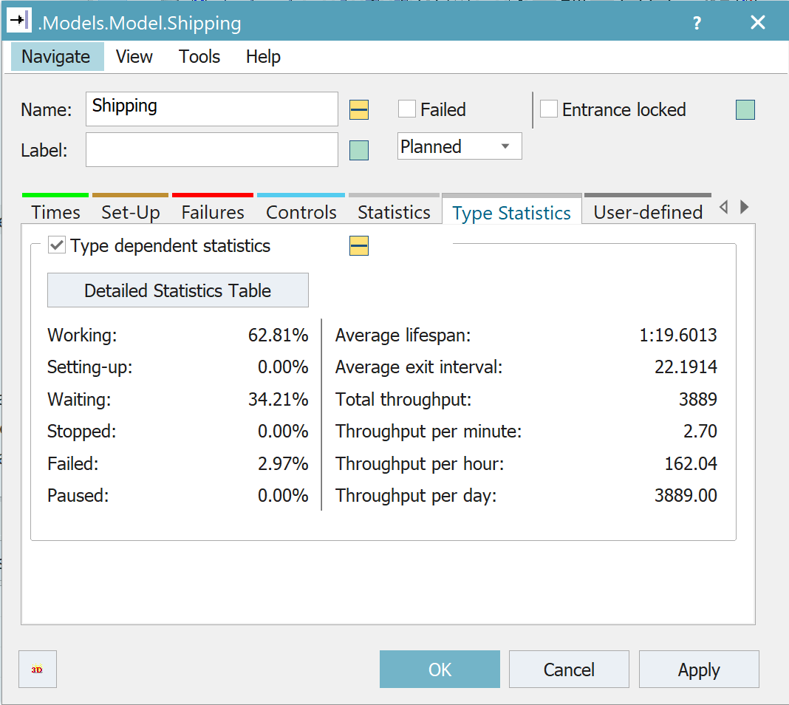

Through our experimentation with Tecnomatix, we were able to learn a lot about our factory set up. We found that after a certain point, increasing the buffer size did not increase the production rate, so it took some trial and error to find the buffer size that was the smallest possible to maintain the production rate. Additionally we found that it was very hard to 10x or 50x the production rate without making the cycles times very small. Often these cycle times would be unrealistic so there would be no feasible way to meet some of these demands. Perhaps adding more machines would help but in the scope of our exploration, it was very difficult. We also found that the cycle of the thermoform machine could slow down the process greatly. Another facet we tried to explore was optimizing the machines for waiting time and working time. Ideally the machine would have about equal work and wait time (green and gray) and no blockage (red). By looking at the statistics report generated by the simulations it became clear that although this configuration works, it is not the optimal configuration for preventing blockages, and balancing the amount of work time and wait time.The work, wait and block times are shown below with our current configuration:

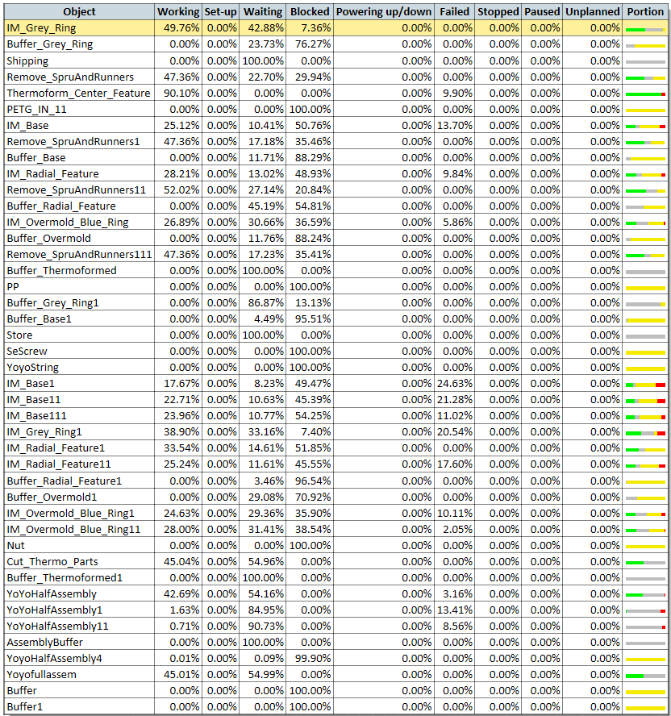

**4. Cost Analysis**

**4a) Documented costs of “inputs”**

|  |  |  |
| --- | --- | --- |
| **Machine cost** |  | **comments** |
| **IM machine cost ($/machine)** | **$50,000** | <https://www.alibaba.com/product-detail/230ton-high-speed-thin-wall-plastic_60569589519.html?spm=a2700.7724857.normalList.82.114c669bMRncjx> |
| **Thermoform machine cost ($/machine)** | **$6,000** | <https://www.alibaba.com/product-detail/Automatic-blister-thermo-vacuum-forming-machine_60750021986.html?spm=a2700.7724857.normalList.66.53b75c0ctT8aSp> |
| **machine lifetime (years)\*** | **10** |  |
|  |  |  |
| **Tooling Cost** |  |  |
| **cost of one set of IM tooling ($)** | **$170,120** |  |
| **Cost of one set of Thermoform tooling ($)** | **$10,000** |  |
| **tool life (= number of parts each tool set can make)** | **750,000** | **class 102 molds, took mean between 500,000 and 1e6** |
|  |  |  |
| **Material Cost** |  |  |
| **PP density (kg/m^3)** | **913** |  |
| **Part Volume** | **Varies per part** |  |
| **Part Mass** | **Part Volume * Density** |  |
| **material cost($/kg)** | **$1.00** | <https://www.alibaba.com/product-detail/hot-sale-PP-Polypropylene-Virgin-recycled_50045483016.html?spm=a2700.7724857.normalList.38.af02808b71WrRD> |
| **scrap fraction** | **0.1** | <https://www.plastikcity.co.uk/blog/what-is-your-real-scrap-rate/> |
|  |  |  |
| **Overhead cost** |  |  |
| **Assembly workers $/hr** | **15** |  |
| **Machine operators $/hr** | **20** |  |

**4b)**

Please refer to the spreadsheet for information on how the following graphs were calculated.

**Base:**

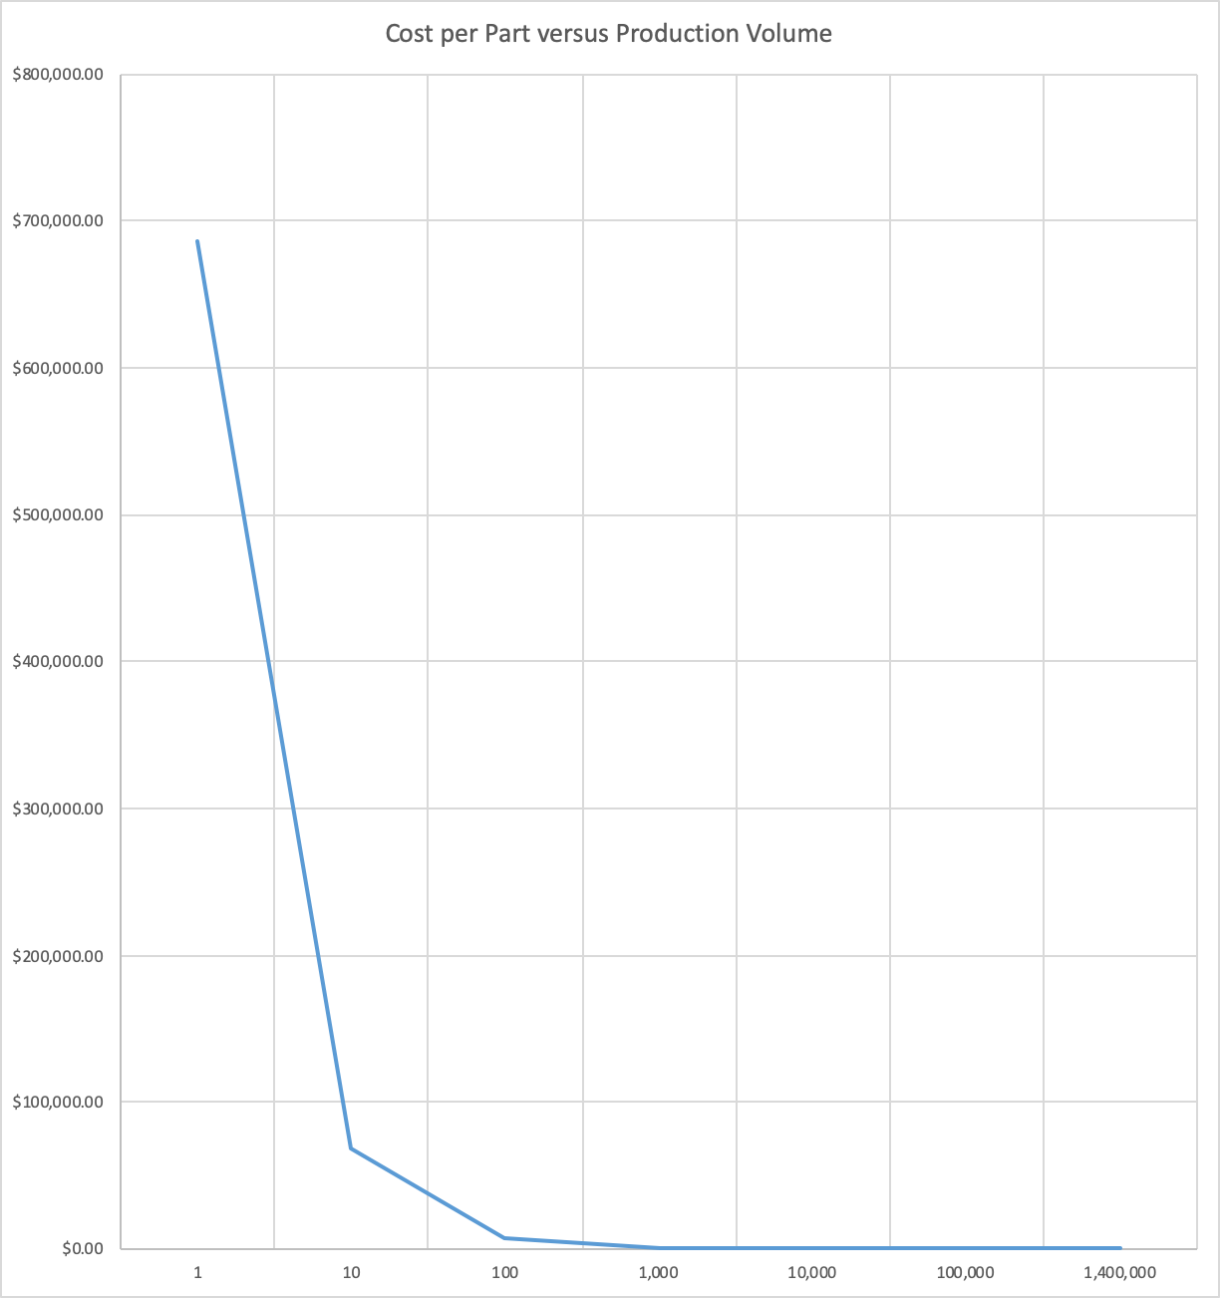

Cost @ target volume of 1,400,000 = $0.50

**Radial Ring:**

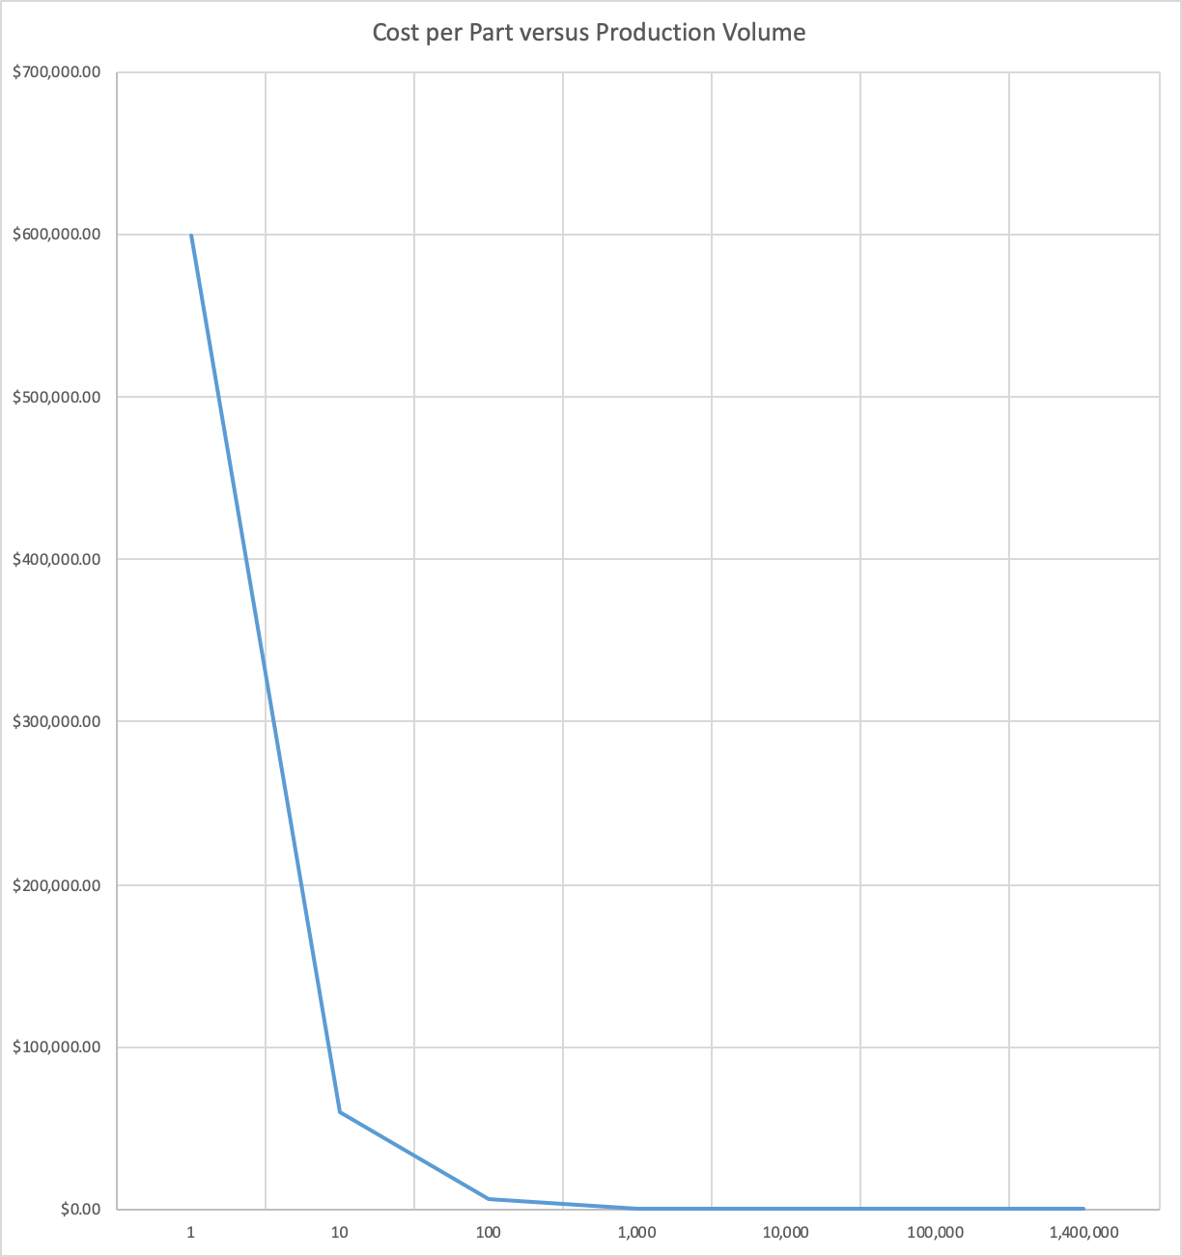

Cost @ target volume of 1,400,000 = $0.43

**Blue Snap Ring:**

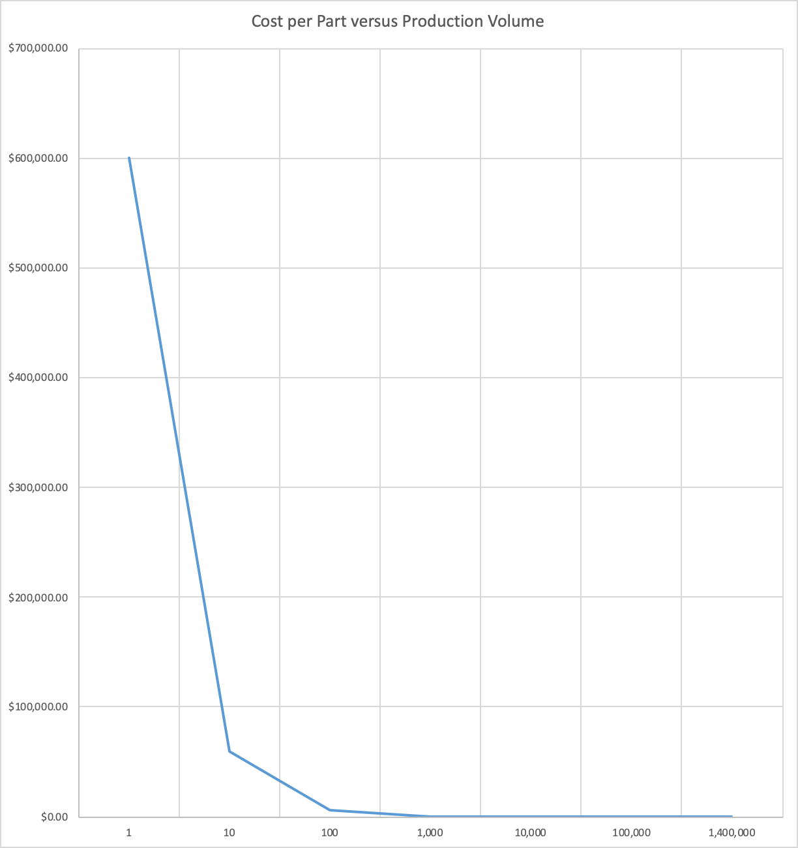

Cost @ target volume of 1,400,000 = $0.44

**Grey Snap Ring:**

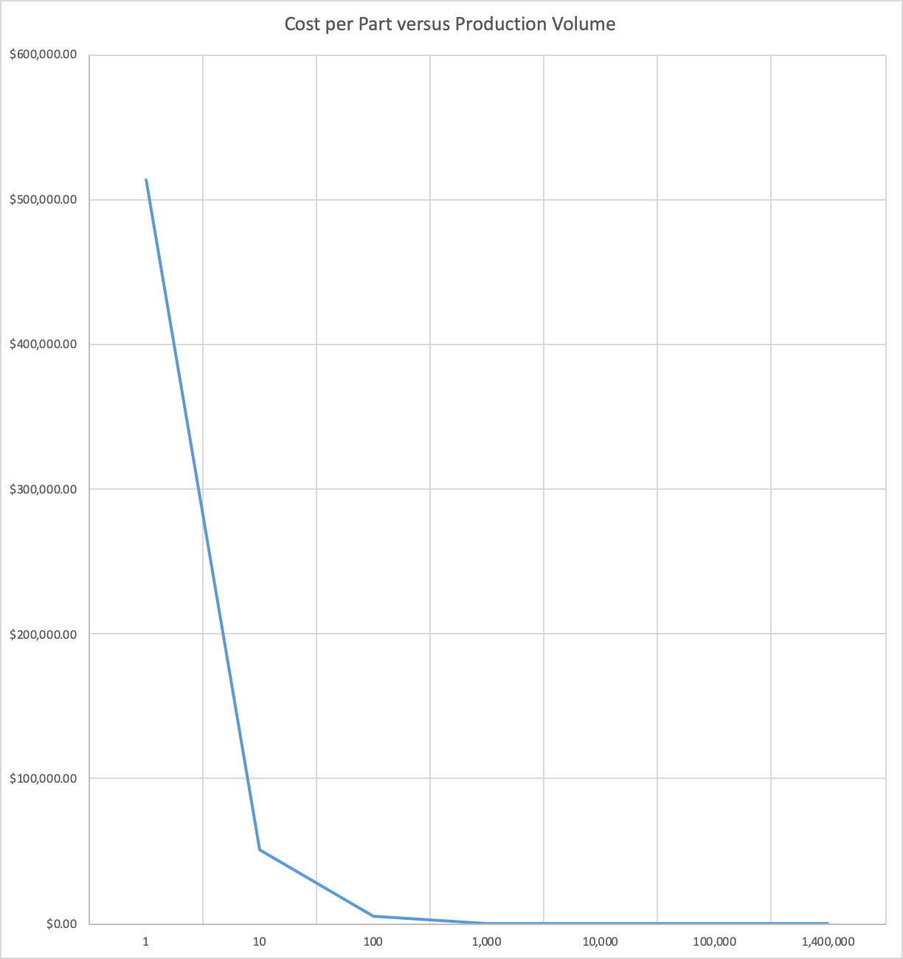

Cost @ target volume of 1,400,000 = $0.37

**Center Feature:**

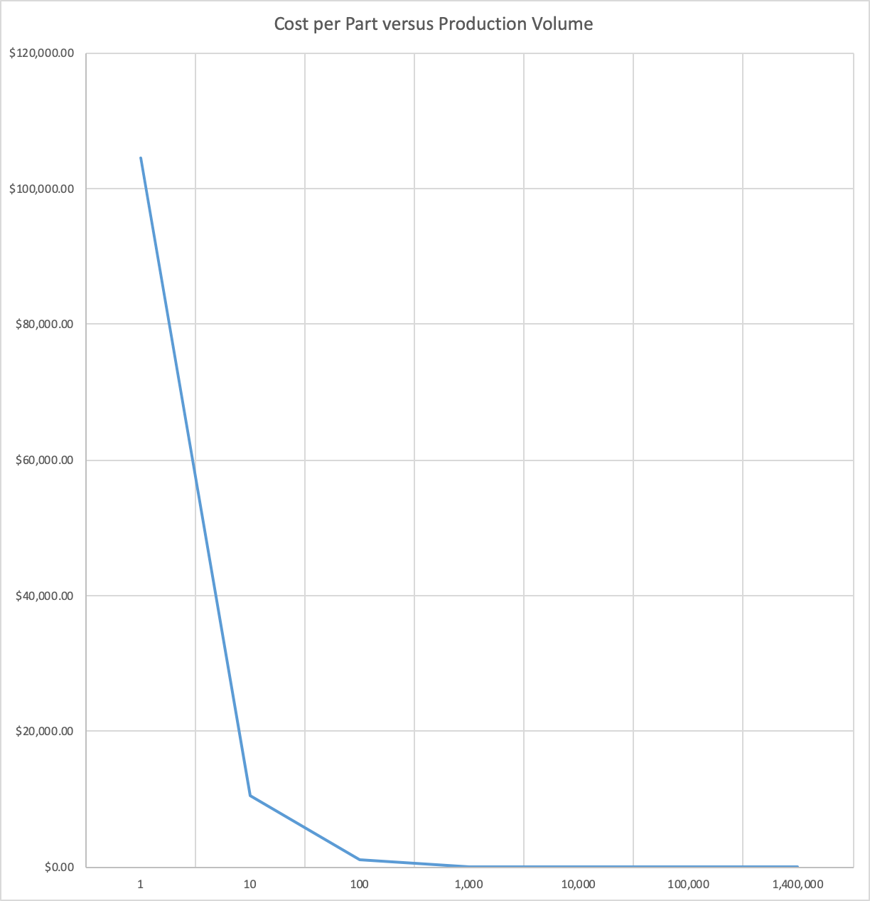

Cost @ target volume of 1,400,000 = $0.08

**4c)**

|  |  |
| --- | --- |
| **Part Cost @ production level of 1,400,000** | **Cost ($)** |
| **Base** | **0.50** |
| **Radial Ring** | **0.43** |
| **Blue Snap Ring** | **0.44** |
| **Grey Snap Ring** | **0.37** |
| **Center Feature** | **0.08** |
| **Nuts** | **0.10** |
| **String** | **0.05** |
| **Threaded rod** | **0.15** |
|  |  |
| **Assembly Cost @ production level** |  |
| **Assembly Worker** | **$15/hour** |
| **Time to assembly Yo-yo** | **1min** |
| **Total cost per Yo-Yo** | **0.25** |
|  |  |
| **Total Cost** | **$2.36** |

To reach this cost per Yo-Yo, we made some assumptions. We were mainly focused on Material, Machine and Labor costs, and are not considering energy costs, rental of manufacturing space, buffer costs (because yo-yo parts are small so cost to store is small), administrative costs and advertising costs etc.

**4d) Reflection on realism of the analysis**

Through research, we found that Amazon sells Yo-Yo’s for less than $10. The cheapest Yo-Yo found was one that costs $3 (<https://www.amazon.com/Duncan-Imperial-Assorted-colors-Pack/dp/B000H6DY5U/ref=sr_1_3?dchild=1&keywords=yoyo&qid=1589178828&sr=8-3>)

Considering that our estimated cost per Yo-Yo is $2.36 (not including costs due to the assumptions explained above), this product would not allow for much profit if the Yo-Yo sells for $3. Thus, we would consider our cost per Yo-Yo more expensive than what companies out in industry can produce them at. This difference could be caused by inefficiencies in our factory set up. (We optimized as best we could through simulation, but more optimization would be needed once the real factory is created). We also assumed that we would pay our workers $15 an hour, to provide a more livable wage. However, this ends up being a large expense and adds to the cost of the Yo-Yo.

Here is the cost breakdown for our thermoformed part. As you can see, overhead cost (labor costs) account for around 75% of the cost for the part.

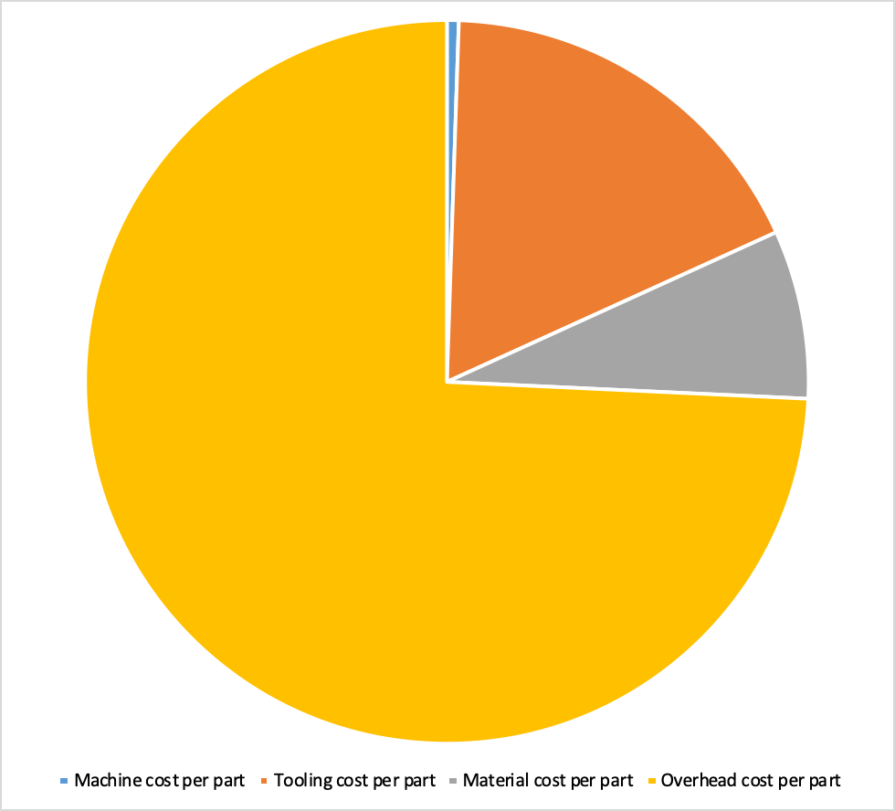

By contrast, other companies probably manufacture their Yo-Yos in other countries where they can pay their workers less.

**4e)**

Using automation, we can reduce the cost of our Yo-Yo. As explained above, labor costs are a large portion of our total costs. By eliminating human workers, we can reduce our overhead cost and overall cost. Advantages for automation include a more consistent product with less errors, shorter cycle times, less risk for humans to get hurt, and no complaining about repetitive or boring tasks. Disadvantages for automation include a large upfront investment cost, disparaged workers, downtime for machine repairs, and less flexibility. Since our Yo-Yo cost is heavily dependent on labor cost, If we were to increase our output 100-fold, we would definitely want to find a way to automate our process.

**4f) Please refer to the attached spreadsheet**

**5. Reflections**

**What we learned while Virtual:**

With the virtual instruction we were able to learn the MoldFlow software, the Technomatrix software, setting up a factory for mass production and a lot of cost analysis.

**MoldFlow software:**

* We learned how to simulate injection molding through MoldFlow
* We learned how to optimize gate locations, check for injection quality, sink marks, cooling time and shrinkage, which could be very useful out in industry
* We learned how to incorporate MoldFlow feedback into our Yo-Yo designs

**Tecnomatix Software:**

* We got a taste of what it could be to set up a large factory to produce millions of these Yo-Yos
* We learned how to use the new software to create assembly stations, machines etc
* We learned how optimize output by changing buffers and the number of machines

**Lessons that we found most valuable:**

* Panel of experts - it was neat to hear about what people do in the manufacturing industry
* Tolerance analysis lecture - this is a super important topic that would have helped us make our Yo-Yo parts fit together and is applicable whenever you make something
* Simulation tools to optimize before you try something in real life; this will be useful if we pursue a career in industry
* In person Lab classes where we learned about machining molds and how the Injection Machine and Thermoforming machine work

**Lessons that we found least valuable:**

* System Design - this lecture had a lot of material without any activity or way to digest the information before we had to do a homework and take a quiz on the material
* Cost Analysis lecture - again, this lecture had a lot of material without any way to support the information presented

**Lessons that we found most interesting:**

* In person labs, especially the Thermoform mold machining and measurement activity
* Additive Manufacturing lesson - it was interesting to hear Professor Hart talk about some of the work he is doing in Additive Manufacturing

**Lessons that we found least interesting:**

* System Design Lecture - this lecture had no interactive parts

**Appendix:**

**Cycle time Breakdown:**

|  |  |  |  |  |  |
| --- | --- | --- | --- | --- | --- |
| **Base** |  |  |  |  |  |
| **Step** | **Process** | **Time (Seconds)** |  |  |  |
| 1 | Insertion of hex nut into mold | 3 |  |  |  |
| 2 | Mold shut time | 1 |  | Cycle time (Seconds) | 18.1 |
| 3 | Injection time | 1.3 |  |  |  |
| 4 | Cooling time | 10.8 |  |  |  |
| 5 | Mold open and ejection | 2 |  |  |  |
|  |  |  |  |  |  |
| **Grey Snap Ring** |  |  |  |  |  |
| **Step** | **Process** | **Time (Seconds)** |  |  |  |
| 1 | Mold shut time | 1 |  |  |  |
| 2 | Injection time | 0.15 |  |  |  |
| 3 | Cooling time | 13.9 |  | Cycle time (Seconds) | 17.05 |
| 4 | Mold open and ejection | 2 |  |  |  |
|  |  |  |  |  |  |
| **Blue Snap Ring** |  |  |  |  |  |
| **Step** | **Process** | **Time (Seconds)** |  |  |  |
| 1 | Insertion of radial feature | 3 |  |  |  |
| 2 | Mold shut time | 1 |  | Cycle time (Seconds) | 22.13 |
| 3 | Injection time | 1.23 |  |  |  |
| 4 | Cooling time | 14.9 |  |  |  |
| 5 | Mold open and ejection | 2 |  |  |  |
|  |  |  |  |  |  |
| **Radial Feature** |  |  |  |  |  |
| **Step** | **Process** | **Time (Seconds)** |  |  |  |
| 1 | Mold shut time | 1 |  |  |  |
| 2 | Injection time | 1.5 |  | Cycle time (Seconds) | 16.5 |
| 3 | Cooling time | 12 |  |  |  |
| 4 | Mold open and ejection | 2 |  |  |  |
|  |  |  |  |  |  |
| **Thermoform piece** |  |  |  |  |  |
| **Step** | **Process** | **Time (Seconds)** |  |  |  |
| 1 | Insert and align plastic | 1 |  |  |  |
| 2 | Heating | 15 |  | Cycle time (Seconds) | 20 |
| 3 | Cooling | 3 |  |  |  |
| 4 | Removing | 1 |  |  |  |